A PROJECT PROPOSAL FOR EMPLOYEE MANAGEMENT SYSTEM

DIT-01-1402/2020 EPHANTUS MULI NZIOKA

DIT-01-0009/2020 JACKLINE WANGUI KARIUKI

DIT-01-1396/2020 CHEPKURUI NAOMY

DBIT-02-7576/2020 KEVIN OKOTH OBURA

Submitted in partial fulfillment of the requirements for the award of Diploma in Information Technology and Diploma in Business Information Technology.

May 2021

# DECLARATION

We declare that this project has not been submitted for any diploma in Zetech University to our knowledge. This project is a product of our effort and research and findings.

**Names**  **Signature**

Ephantus Muli Nzioka ………………………………

Kevin Okoth Obura ………………………………

Naomy Chepkurui ………………………………

Kariuki Jackline ………………………………

**Supervisor’s Name Signature**

Francis Mutuku ………………………………

# 

# DEDICATION

We dedicate this project to our supervisor, friends and family who encouraged and supported us throughout the project.

# 

# ACKNOWLEDGEMENT

We give special thanks to our supervisor who helped with the explanation on the areas we needed to concentrate during the project. We thank the almighty God who gave us the strength to complete the project. We also thank our friends and family for their support and encouragement.

# ABSTRACT

Employees are the backbone of any company therefore their management plays a major role in deciding the success of an organization. An employee management system makes it easy for an admin to keep track of all the employee’s records. The system will allow the admin to edit the employee and add new employees.

The system is simple to understand and can be used by anyone who is not even familiar with the system. It is user friendly and it just asks the user to follow step by step operations by giving simple instructions. It will be fast and will perform many operations for a company.

The aim of this project is to design and develop an employee management system to simplify management of employees by large organizations.

TABLE OF CONTENTS

DECLARATION 2

DEDICATION 3

ACKNOWLEDGEMENT 4

ABSTRACT 5

CHAPTER ONE: INTRODUCTION 8

1.0: INTRODUCTION 8

1.1: PROBLEM STATEMENT 8

1.2: OBJECTIVES 8

1.2.0: Main objective 8

1.2.1: Specific objectives 8

1.3: SIGNIFICANCE OF THE STUDY 9

1.4: LIMITATIONS OF THE STUDY 9

1.5: SCOPE OF THE STUDY 9

CHAPTER TWO: LITERATURE REVIEW 10

2.0: INTRODUCTION 10

2.1: GLOBAL LITERATURE REVIEW 10

2.2: REGIONAL LITERATURE REVIEW 10

2.3: LOCAL LITERATURE REVIEW 10

2.4: CONCLUSION 11

CHAPTER 3: METHODOLOGY 12

3.0: SYSTEM DEVELOPMENT TECHNIQUE 12

3.0.1: Prototyping 12

3.0.2: Modeling 12

3.1: SYSTEM DEVELOPMENT METHODS 12

3.1.0: Waterfall model 12

3.1.1: Advantages of waterfall model 12

3.1.2: Disadvantages of waterfall model 13

3.2: CODING LANGUAGES TO BE USED 13

3.2.1: Database management system 13

3.2.2: Back-end technology 13

3.2.3: Front-end technology 13

3.3: TESTING PLAN FOR THE SYSTEM 14

3.3.1: Unit testing 14

3.3.2: Component testing 14

3.3.3: Integration testing 14

3.3.4: System testing 14

3.4: SYSTEM REQUIREMENTS ANALYSIS 14

3.4.1: Functional requirements 15

3.4.2: Non-functional requirements 15

CHAPTER 4: SYSTEM ANALYSIS AND DESIGN 15

4.0: SYSTEM ANALYSIS 15

4.1: SYSTEM DESIGN 16

4.2: CODE 16

4.2.0: Login Interface 16

4.2.1: Leave Interface 17

4.2.2: Assign project interface 18

4.2.3: Payroll interface 19

4.3: TRIAL RUNS 19

CHAPTER 5: WORK PLAN AND BUDGET 20

5.0: BUDGET (Resources Required for the Project) 20

5.1: GANTT CHART (Project Schedule) 20

5.2: CONCLUSION 20

5.3: RECOMMENDATION 20

5.4: REFERENCES 20

# CHAPTER ONE: INTRODUCTION

## 1.0: INTRODUCTION

In large organizations there are a huge number of employees, at this time an employee management system becomes a desire for the company to keep. The system can manage admin activities in an easier and quick way. The employee management system aims at providing an effective and efficient way to manage the employees in the organization. Employees are the pillar of an organization and an ideal employee management tool makes a big difference to an organization. Every organization whether government or private uses an information system to store data of their staff. Most of the contemporary information system is based on the database technology as a collection of logical related data, and database management system as a software system allowing the user to define, create, maintain and control access to the database. The system allows the administrator to edit employees, add new employees as well as evaluate an employee’s performance. This system brings about an easy way of maintaining the details of employees working in any organization.

## 1.1: PROBLEM STATEMENT

Employee information handled manually poses a number of challenges such as; leave management where an employee is required to fill in a form which may take a long time to be approved. The use of paper work in handling some of these processes could lead to human error may land in the wrong hands and it is also time consuming. Most systems lack employee self-service meaning employees are not able to manage their personal information directly.

The said problems can be solved by creating and designing an employee management system which will maintain the employee’s information in a secure database.

## 1.2: OBJECTIVES

### 1.2.0: Main objective

The main aim of the project is to create an employee management system that keeps track of employee data in the organization.

### 1.2.1: Specific objectives

To create a project assigning module that will allow the admin to allocate projects to the employees.

To create a leave management module that keeps track of employees who take holidays and leaves.

To create a payroll management module that manages the payroll of the employees

To create an employee registration module that will allow the admin to add a new employee in the system.

## 1.3: SIGNIFICANCE OF THE STUDY

It will help in reducing paper work in the organization.

It will help secure employee data

It will allow the organization to keep real-time employee data.

It will allow an admin to access an employee data in the organization.

It will allow the employees to work independently without being supervised.

## 1.4: LIMITATIONS OF THE STUDY

* An employee can be delayed once they request for their leave for it requires approval from the admin
* The admin could give up an employee’s private information to outside source.
* Employees become demotivated due to being unappreciated or unrecognized by the employer.
* Employees could take legal action against the company if they feel like they haven’t been evaluated fairly based on their projects.

## 1.5: SCOPE OF THE STUDY

The employee management system has two major components: Admin and Employee. The Admin is in charge of the company information, leave, payroll, assigning projects and can also add and change the employee details. The Employee can use the system to check their leave status, view salary details, and view and submit their assigned projects.

# CHAPTER TWO: LITERATURE REVIEW

## 2.0: INTRODUCTION

This chapter summarizes the literature review of the Employee Management System. It includes: global literature review, regional literature review, local literature review and conclusion.

## 2.1: GLOBAL LITERATURE REVIEW

Management is not only about managing resources and controlling expenses. Common management issues that organizations face today such as poor leadership, not being able to manage conflicts appropriately and many others. Global organizations have employee management systems that manage their employees in many branches across the globe. An example of such companies is the Coca Cola Company which is a huge company and has different branches across the world. The management system of that company is crucial for smooth running of business activities, it will help manage all their employees’ information and also keep track of their progress in the company. (www.coca-cola.co.ke)

With this in mind, this project will also aid in managing employee data in large companies and organizations as well as keeping track of the employee’s progress.

## 2.2: REGIONAL LITERATURE REVIEW

A recent study by the Hackett Group, a business process advisory firm found that high performing organizations spend 25% less than the peers on HR because they use technology efficiently. The two most popular web based HR applications used today are self-service for employees and self-service for managers. These applications have enabled companies to shift responsibility for viewing and updating records onto individual employees and have fundamentally changed the manner in which employees acquire information and relate to the HR departments.(www.thehackettgroup.com)

With this in mind, this project will also adapt the self-service procedure which will allow the employees and admin to edit and update their information.

## 2.3: LOCAL LITERATURE REVIEW

Export processing zones (EPZs) are designated parts of Kenya that are aimed at promoting and facilitating export oriented investments and to develop an enabling environment for such investments. Currently there are over 40 gazetted zones in Nairobi, Voi, Athi River, Kerio Valley, Mombasa and Kilifi in various stages of development by both private and public zone developer/operators. In order to manage all the employees in these branches, an employee management system has been designed so as to keep track of each employee’s progress and real time information. During payment dates, employees are able to interact with the system so as to request for their monthly payment through the payroll. (https.invest.go.ke)

With this in mind, our system will be able to allow the employees to fill in their required information so as to request for their payment.

## 2.4: CONCLUSION

From the three case studies discussed our system will also include some of their unique features. The features include:

1. Managing employee data and keeping track of each employee’s progress in an organization.
2. Allow the employees and admin to interact with the system so as to edit and update their information.
3. The employees will be able to request for their payments through the system if their details are in the payroll.

# CHAPTER 3: METHODOLOGY

This chapter will deal with the system development technique, tools used, the coding languages used, the testing plan of the system and the system requirement analysis.

## 3.0: SYSTEM DEVELOPMENT TECHNIQUE

### 3.0.1: Prototyping

It tests system concepts and provides an opportunity to examine input, output and user interfaces before final decisions are made. A prototype can serve as an initial model that is used as benchmark to evaluate the finished system or the prototype itself can develop into the final version of the system.

### 3.0.2: Modeling

It produces a graphical representation of a concept or process that system developers can analyze, test and modify. A system analyst can describe and simplify an information system by using a set of business, data, object, network and process models

## 3.1: SYSTEM DEVELOPMENT METHODS

### 3.1.0: Waterfall model

It is a rigid linear model that consists of sequential phases that focuses on distinct goals. Each phase must be complete before the next phase starts. We will use this model to develop our project because it is well suited for teams.

### 3.1.1: Advantages of waterfall model

1. It uses a clear structure and has a defined set of steps
2. It determines the end goal early
3. Allows for easy transfer of information from one step to another
4. Testing is easy

### 3.1.2: Disadvantages of waterfall model

1. It delays testing until after completion.
2. It makes changes difficult.

## 3.2: CODING LANGUAGES TO BE USED

### 3.2.1: Database management system

1. MS SQL (Microsoft SQL server)

It is a Microsoft’s relational web hosting database used to store website information like user information, it’s mostly used on windows servers and it is not free. It has advanced features such as a buffer management, logging and transaction, concurrency and locking and stored procedures and triggers. MS SQL databases work well with ASP.NET and also integrate well with other Microsoft products.

It has been used to support large enterprise applications worldwide, it’s most common use is to store data for customer relationship management systems in large organizations that need to keep track of their customer’s data.

### 3.2.2: Back-end technology

1. PHP (Hypertext Preprocessor)

It is an open source server side scripting language that is platform independent, meaning it can work on all major operating systems. It supports many types of databases including MS SQL and is supported by large community of users and developers.

It is an excellent choice for developing web based systems because it is an open source technology and has a large community of users and developers, this makes PHP a language that is easy to learn and understand and furthermore coding solutions and bugs are resolved quickly. PHP has the ability to integrate with most web technologies thus it can be used as a middleware.

### 3.2.3: Front-end technology

1. HTML

It stands for Hyper Text Markup Language. It is used to design the front end portion of web pages using markup language. HTML is easy to use and learn by anyone. Hypertext defines the link between the web pages. The markup language is used to define the text documentation within tag which defines the structure of web pages.

1. CSS

Cascading Style Sheets fondly referred to as CSS is a simply designed language intended to simplify the process of making web pages presentable. CSS allows you to apply styles to web pages. More importantly, CSS enables you to do this independent of the HTML that makes up each web page.

1. JavaScript

It is a famous scripting language used to beautify sites and make the site interactive for the user. It is used to enhancing the functionality of a website to running cool games and web-based software.

It is a runtime language for web browsers. This means that when you open a web page the page will load both the foundational JavaScript that is standard with the page and any new JavaScript added to the page. It is very fast, has less server interaction, has increased interactivity making it efficient to use.

## 3.3: TESTING PLAN FOR THE SYSTEM

A system test plan details the complete approach to the validation of the system under test. It generally contains glossary terms, the objectives of the system test, the testing approach risks, deliverables and defect management

### 3.3.1: Unit testing

It ensures that each part of the code developed in a component delivers the desired output. In unit testing, developers only look at the specification and interface of a compound. It provides documentation of the code development as each unit of the code is tested alone before progressing to another unit.

### 3.3.2: Component testing

It is testing a module independently to verify its output. It is done to verify the usability and functionality of a module

### 3.3.3: Integration testing

It is performed to test individual modules and check how they function together. This type of testing will be done once each module is complete

### 3.3.4: System testing

It is done on a complete system to evaluate its compliance with the specified requirements. It verifies that the system needs the functional and technical requirements that were set by the developers.

## 3.4: SYSTEM REQUIREMENTS ANALYSIS

It focuses on the tasks that determine the conditions to be met on the project taking account of the possibly conflicting requirements

### 3.4.1: Functional requirements

1. Payroll module - It will allow the admin to allocate salaries to the employees and also allow the employees to view their allocated salary.
2. Assign project module - It will enable the admin to allocate projects to the employees and also allow the employees to view the assigned projects.
3. Leave and holiday module - It will allow employees to request for leave, view previous leave history and the employer can review can approve leave requests and keep track of the employees who are currently in leave.
4. Employee registration module - It will provide an interface for an employee to login to the system and also allow a new employee to be registered into the system.

### 3.4.2: Non-functional requirements

* The system will be user friendly
* The system will help in reducing paper work in the organization.
* The system will be secure hence protecting the employee data in the organization.
* The system will be portable hence can be used on different devices.

## CHAPTER 4: SYSTEM ANALYSIS AND DESIGN

## 4.0: SYSTEM ANALYSIS

System analysis is conducted for the purpose of studying a system or its parts in order to identify its objectives. It is a problem solving technique that improves the system and ensures that all the components of the system work efficiently to accomplish their purpose.

## 4.1: SYSTEM DESIGN

It is the process of designing system elements such as modules, architecture, components and the data that goes in the system.

New employee

Admin

Gets employee details

Login details

Receives verification

Registers the new employee

*Fig 1.1:DFD of Login module*

Receives leave application

Leave application

Admin

Employee

Receives response

Approve or disapprove

Receives submitted project

*Fig 1.2: DFD of Leave module*

Submit project

Admin

Employee

Receive marks

Assign project

*Fig 1.3: DFD of Assign project module*

Check salary

Admin

Employee

Update salary status

*Fig 1.4: DFD of payroll module*

## 4.2: CODE

The system will be implemented using different coding languages for front end and backend so as to generate the desired output.

### 4.2.0: Login Interface

The login interface will allow a user to login to the system or to register in the system.

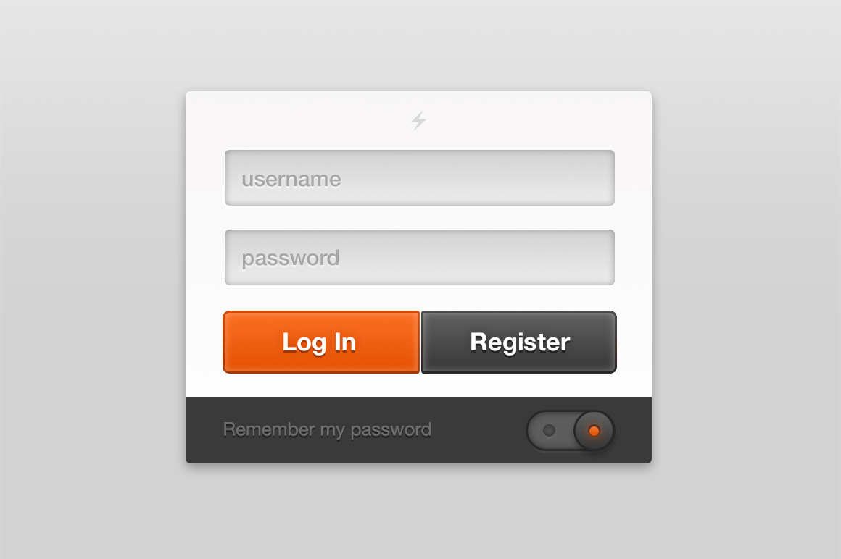

### 4.2.1: Leave Interface

The interface shows how the employee should apply for their leave and the duration.

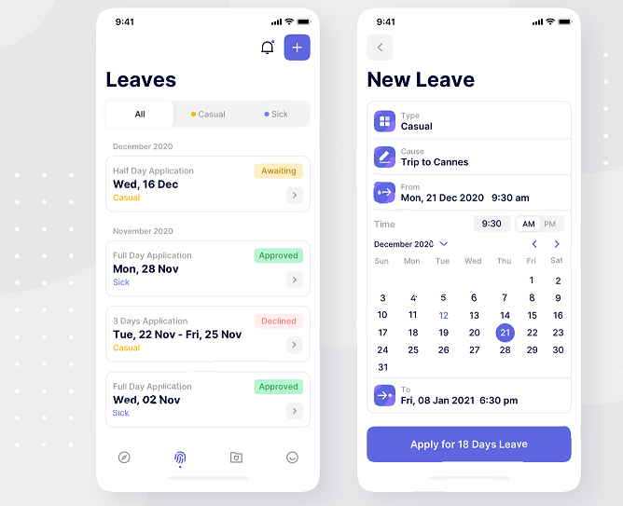

### 4.2.2: Assign project interface

The assign project interface will allow the admin to assign projects to the employees.

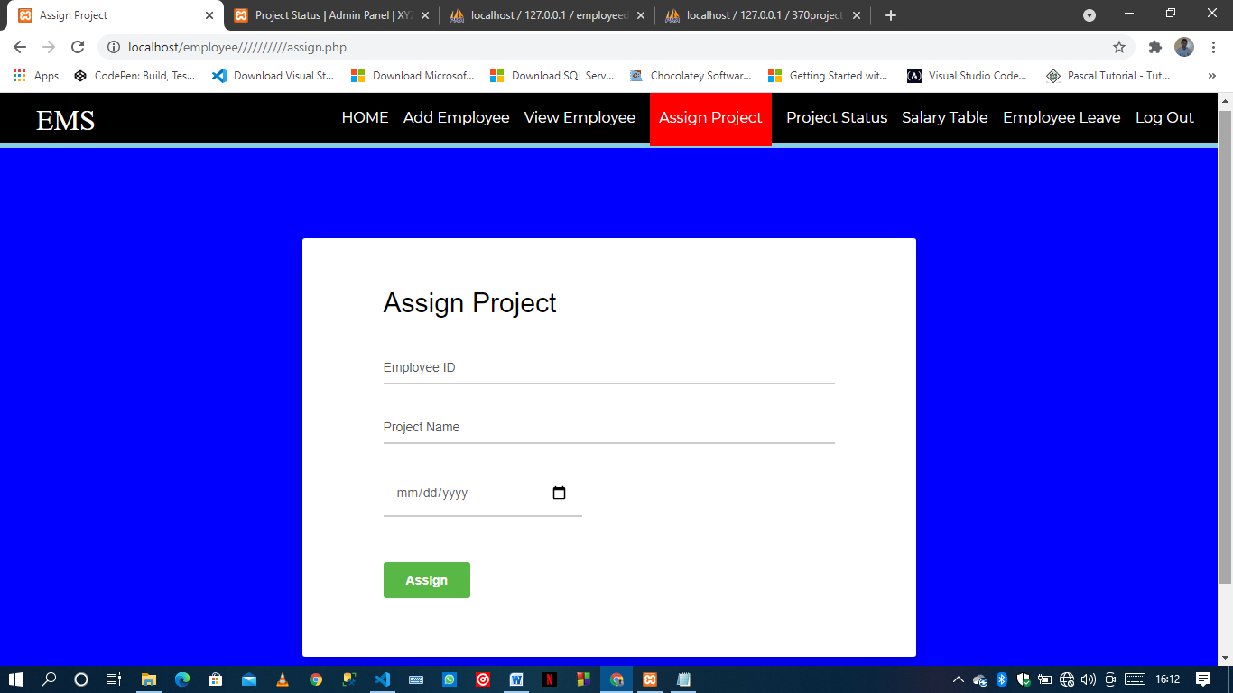

### 4.2.3: Payroll interface

The payroll interface will allow the admin to update the employee salaries to the system so that the employees can view their allocated salary.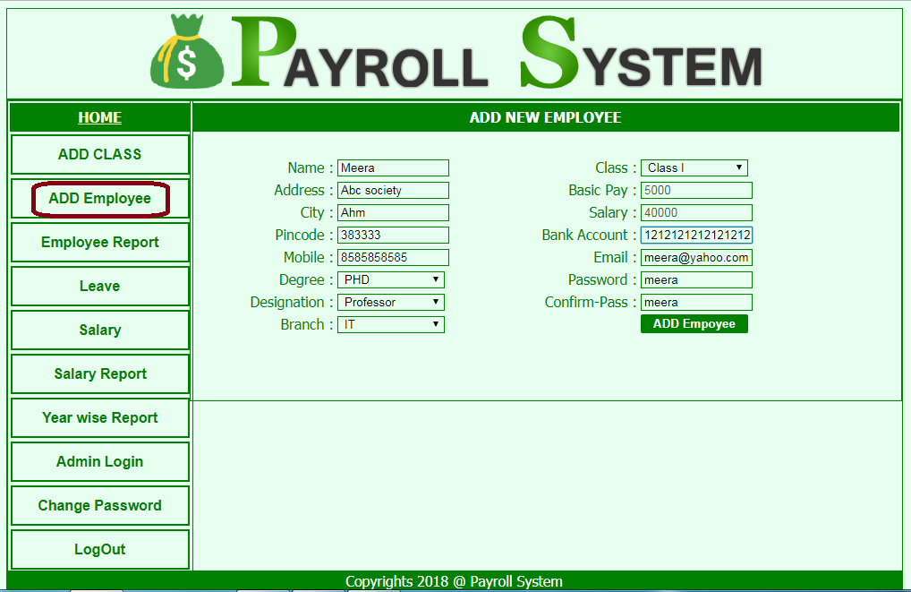

## 4.3: TRIAL RUNS

A trial run is a preliminary test of how a new system works. Trial runs for our system will be done once all the modules are complete and compiled. The trial runs will evaluate the success or failure of the system.

# CHAPTER 5: WORK PLAN AND BUDGET

## 5.0: BUDGET (Resources Required for the Project)

In order to complete this project the following resources are required:

* A laptop.
* Stationery equipment’s.
* Stable internet connection.
* Compiler applications.
* Funds to buy the resources.

## 5.1: GANTT CHART (Project Schedule)

A Gantt chart is a project management tool that helps in planning and scheduling of projects.

|  |  |  |  |  |  |
| --- | --- | --- | --- | --- | --- |
|  | 1st week | 2nd week | 3rd week | 4th week | 5th week |
| Requirements |  |  |  |  |  |
| Design |  |  |  |  |  |
| Implementation |  |  |  |  |  |
| Verification |  |  |  |  |  |
| Maintenance |  |  |  |  |  |

## 5.2: CONCLUSION

This project will be used to manage employees in an organization, institution, companies, etc. The project will be developed using HTML, CSS, PHP, MY SQL and JAVA SCRIPT. The project will be of great assistance because it will reduce a lot of manual labor and paper work.

## 5.3: RECOMMENDATION

We recommend this system to organizations because we believe it will be quite beneficial to them to keep track and also manage the huge number of employees available in the organization.

## 5.4: REFERENCES

* https.invest.go.ke
* www.thehackettgroup.com
* www.coca-cola.co.ke